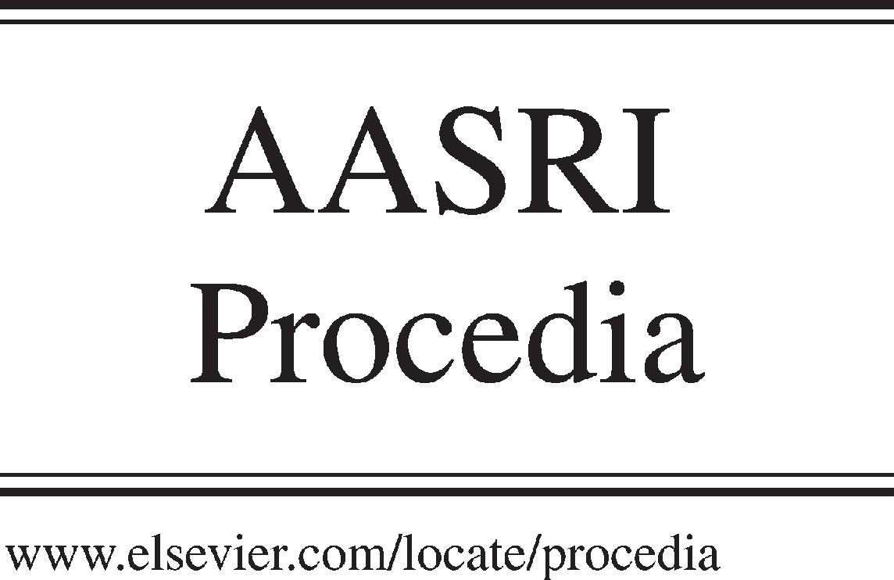Available online at [www.sciencedirect.com](http://www.sciencedirect.com/)



AASRI Procedia 3 (2012) 642 – 645

2012 AASRI Conference on Modeling, Identification and Control

Modeling of Shot Peening Parameters for Weight Reduction of EN45A Spring Steel Leaf Springs

M.L. Aggarwal

*Professor in Department of Mechanical Engineering and Dean Academic Affairs, YMCA University of Science &Technology,*

*Faridabad-121006,Haryana,India Tel.:+919810971654,* [*E-mail:acadymca@rediffmail.com*](mailto:acadymca@rediffmail.com)

Abstract

A lot of research has been done to improve the fatigue strength of materials by creating compressive residual stress field in their surface layers through the shot peening. In the present work, it is found that relaxed residual stress field varies with shot peening intensity and affects weight of EN 45A spring steel leaf springs. A stress approach model for weight reduction of leaf springs used in automotive vehicles has been experimentally developed simulating with industrial environment. Paper discusses a time saving and reliable method of predicting thickness and weight of leaf springs at various shot peening intensities for industrial applications. A model based on experimental results has been developed which predicts weight reduction of leaf springs for a given stress at varying shot peening conditions.

© 2012 The Authors. Published by Elsevier B.V. Open access under [CC BY-NC-ND license.](http://creativecommons.org/licenses/by-nc-nd/3.0/)

© 2012 The Authors. Published by Elsevier B.V.

Selection and/or peer review under responsibility of American Applied Science Research Institute

Selection and/or peer review under responsibility of American Applied Science Research Institute

Keywords: Design parameters; weight reduction; stress approach; leaf springs.

1. Introduction

The complexity of the increasing expanding global competition and technologies led to various attempts to develop structures for systematic treatment. Present trend in industry is to use cheaper material with improved mechanical properties to ensure reliability of structures. This can be accomplished by various treatments including shot peening. There are various types of adjustments in the machine but in the present work shot flow rate was changed to achieve required Almen intensity, and other parameters were kept constant.

There is growing demand from the industries for the development of new concepts and model to meet

2212-6716 © 2012 The Authors. Published by Elsevier B.V. Open access under [CC BY-NC-ND license.](http://creativecommons.org/licenses/by-nc-nd/3.0/) Selection and/or peer review under responsibility of American Applied Science Research Institute doi:10.1016/j.aasri.2012.11.102

*M.L. Aggarwal / AASRI Procedia 3 (2012) 642 – 645* 643

the new challenges in the field of manufacturing engineering. Vinkel Arora et al., 2011 suggested that computer aided model of leaf springs may be prepared in CATIA and analysed in ANSYS. The CAE analysis of leaf springs was performed for various design parameters and loading conditions. The main objective of the work was to reduce the time and cost related to actual experimental set up by providing CAE solution. It was concluded in the paper that CAE tools provide a cost effective and less time consuming solution in comparison with experimental testing but the error may vary in the specified range.

Most of researchers focused on improving fatigue resistance of structures by using shot peeing process to impart compressive stresses in the surface layers which opposes tensile load on structures like suspension system of vehicles. Schijve J., 2003 recommended that accurate fatigue predictions for full- scale testing which designers prefer are still unpredictable. In the previous studies, the possibility of weight reduction of components by varying intensity was not considered. In the present work, the estimation of weight reduction at various shot peening intensities of leaf springs has been discussed through computational methods.

1. Experimental work

The leaf springs were having two full length leaves and six graduated leaves. The remaining parts were rebound clip of MS, Centre bolt, nut and bronze bush. Leaf springs specifications were :force applied at both the ends of the springs = 3160 Kg ,centre to centre distance = 3160 Kg ,width of each leaf 70mm and total length of all laminated leaves =8.195 m. EN45A spring steel was containing 0.61 C with other alloying elements such as Si, Mn, S, P to ensure adequate hardenability of the thick sections . The details of the chemical composition of the material and the mechanical properties of the chosen material have been described by Aggarwal et al., 2006. Fixtures were used to hold the Almen strip in place and the strip was exposed to same shots as experienced by the leaf springs. Varying deflection was observed at different intensity of shots and the intensity was measured using an Almen gauge. 0.1 mm deflection (arc height) of Almen strip was designated as 4A. Leaf springs were shot peened by cast steel ball of 1.0 mm in diameter.

1. Cyclic-stress curve

Cyclic-stress curves as per ASTM specifications of specimens were determined using an axial fatigue-testing machine. The S/N curves were plotted as per standard procedure mentioned by Aggarwal et al., 2005. Laboratory testing of leaf springs was done on a test rig and bending stress was calculated as per formula mentioned by Aggarwal et al., 2006. The static stress of 432 MPa was applied to leaf springs by hydraulic ram. Hydraulic actuators limits were set according to alternating load and stress ratio of 0.5 was used. The unpeened and shot peened material was subjected to shots of varying intensity and each time improvement in fatigue life was recorded.

1. Reduction in weight
   1. *Residual Stress*

For the determination of compressive residual stress changing with depth, the layers of strip of 3 x 7 mm on test shot peened specimen were removed by electrochemical machining. The compressive residual stress field (CRSF) induced by shot peening was determined by X-ray diffraction method, using the Raystress equipment. The accuracy of stress measurement was **   20 MPa.

As the distance from surface increases, compressive residual stress was different at various shot peening intensity. The improvement in fatigue life was a consequence of the compressive residual stress field

644 *M.L. Aggarwal / AASRI Procedia 3 (2012) 642 – 645*

induced by shot peening. Almen intensity affects were observed up to optimum shot peening condition (18A). At an intensity higher than 18A, cracks were initiated which leads to early fatigue failure of metal.

Additional tests were performed to verify the possible variation of the residual stresses induced by shot peening under cyclic loading. It was found that relaxation of compressive residual stress field (RCRSF) occurred after a definite number of fatigue cycles due to opening /propagation of micro cracks and the same was measured on specimens by X-ray diffraction technique. Greater the stress CRSF relaxation, the lesser is the fatigue life.

* 1. *Steps for Modelling*

A systematic procedure for improvement in fatigue design has been experimentally developed simulating with the experimental data. The improvement in fatigue design was carried out in following steps:

1. Aggarwal et.al, 2005 experimentally predicted fatigue life of leaf springs:

Stress = 370 FSCF + 566 (1)

FSCF = Fatigue life of leaf springs (NL) / Specimen life from S-N Diagram (Ns) (2) The value of Fatigue life of leaf springs (NL) shall be different at different shot peening intensity as the fatigue life of specimen is different.

1. Improved fatigue life (Aggarwal et al., 2008):

Surface roughness improvement increases fatigue life. Double shot peening decreases surface roughness without significant change in residual stress:

Improved fatigue life = (1.15) Maximum NL (3)

1. Reduction in weight suggested by Aggarwal et al., 2006:

*Sy*  *RCRSF*

Permissible bending stress ( ** *b* ) =

*FOS*

(4)

Weight of leaf springs =

** *xL t bt*

(5)

Table1 shows the effect of Almen intensity on fatigue design and weight reduction of leaf springs.

1. Conclusions

Computational methods have accomplished followings for leaf springs in industries:

1. Designing various components, keeping into account the effect of shot peening intensity, will eliminate failure of existing design, reduce the weight of components and increase reliability. Thereby, for large scale production of components, there will be tremendous cost reduction through material saving.
2. A stress approach model for weight reduction of leaf springs at various shot peening intensity used in suspension system of automotive vehicles has been developed in industrial environment. A computer program has been developed for estimating weight reduction at various shot peening intensity.
3. Prediction is found to be useful in a situation when fatigue life of leaf springs is not enhanced in industries due to other factors such as materials, cracks and manufacturing inaccuracies.
4. Almen intensity affects were calculated up to optimum shot peening condition (18A). At an intensity higher than 18A, cracks were initiated which leads to early fatigue failure of metal.

*M.L. Aggarwal / AASRI Procedia 3 (2012) 642 – 645* 645

Table 1. Effect of Almen intensity on weight of leaf springs

|  |  |  |  |  |  |  |
| --- | --- | --- | --- | --- | --- | --- |
| Sr.  No. | Parameters | Base Materi al | Shot peening intensity | | | |
| 6A | 12A | 18A | Remarks |
| 1. | Static Load |
|  | i) Permissible stress (Ssp/) | 721 | 903 | 993 | 1032.5 | Almen intensity |
| MPa |  |  |  |  | affects were |
| Calculated, t (mm) | 12.5 | 11.2 | 10.7 | 10.49 | calculated up to |
| Weight of leaf springs | 58.16 | 50.11 | 47.87 | 46.94 | optimum shot |
| (Kg.) |  |  |  |  | peening condition |
| 2. | Dynamic Load |  |  |  |  | (18A). At an |
| intensity higher |
|  | Fatigue life for alternating | 54604 | 70050 | 88095 | 109405 | than 18A, cracks |
| stress(Cycles) |  |  |  |  | were initiated |
| Fatigue strength(Mpa) | 762 | 795 | 825 | 858 | which leads to |
| Calculated, t (mm) | 12.91 | 12.30 | 11.82 | 11.30 | early fatigue |
| Weight of leaf springs (Kg) | 57.72 | 55.03 | 52.88 | 50.56 | failure of metal. |

References

1. Aggarwal ML, Khan RA and Agrawal VP. Investigation into the effects of shot peening on the fretting fatigue behaviour of 65Si7 spring steel leaf springs, Journal of Materials : Design and Applications 2005,219(3): 139-147.
2. Aggarwal ML, Agrawal VP and Khan RA. A stress approach model for predicting fatigue life of shot peened EN45A spring steel, International Journal of Fatigue 2006, 28(12) : 1845-1853.
3. Aggarwal ML, Khan RA and Agrawal VP. Effect of surface roughness on fretting fatigue behaviour of EN-45A spring steel leaf springs, Journal of Engineering Manufacture 2006, 220(8) :1325- 1333.
4. Aggarwal ML, Khan RA and Agrawal VP. A Novel approach for improving fatigue strength of shot peened surfaces by damping measurements, International Journal of Manufacturing Technology and Research,Vol.2, No.1&2,June 2006 :pp 30-34.
5. Aggarwal ML, Khan RA and Agrawal VP. , When shot-peening does not enhance fatigue life of leaf springs, International Journal of Surface Science and Engg. 2008, 2(3):281-293.
6. Vinkel Arora,Gian Bhushan and Aggarwal ML. Eye design analysis of single leaf spring in automotive vehicles using CAE tools, International Journal of Applied Engg.&Technoloy 2011, 1(1) : 88-97.
7. [Vinkel Arora, Aggarwal ML and Gian Bhushan “A comparative study of CAE and experimental results of leaf springs in automotive vehicles, International Journal of Engineering Science &Technology 2011, 3(9): 6856-66.
8. Schijve J. Fatigue of structures and materials in the 20th century and the state of the art., Int. J Fatigue 2003, 25 (8): pp 679-700.